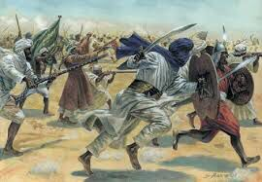

**Project 2025**

**Islamic Wars, Warriors & Legacy**

**Rahim Uddin**

**Department of Bangla**

**EDGE PROGRAM UNIVERSITY OF BARISHAL**

**Table of Contents**

Introduction 3

1. Historical Overview of Islamic Dynasties 3

1.1 Rashidun Caliphate (632-661) 3

1.2 Umayyad Caliphate (661-750) 3

1.3. Abbasid Caliphate (750-1258) 4

1.4 Mamluk Sultanate (1258-1517) 4

1.5 Ottoman Empire (1299-1924) 4

1.6 Safavid Dynasty (1501-1736) 4

1.7 Mughal Empire (1526-1857) 5

1.8 Kingdom of Mysore (1600-1947) 5

1.9 Mughal Decline (1707-1858) 5

1.10 Saudi Kingdom (1858-Present) 5

2. Data Analysis & Insights 6

2.1 Longest Ruling Dynasty 6

2.2 Highest Casualties in Wars 6

2.3 Statistical Calculations 6

3. Advanced Excel Functionalities Used 6

4. Visual Representation 7

4.1 Data table 7

4.2 Bar Chart 7

4.3 Pie Chart 8

4.4 Operations Performed 8

Conclusion 8

The Rise & Fall of Islamic Dynasties: Wars, Warriors & Legacy

# Introduction

Islamic history spans over a millennium, marked by the rise and fall of powerful dynasties that shaped global politics, culture, and religion. From the Rashidun Caliphate to the Ottoman Empire, various Islamic rulers expanded their territories, engaged in significant battles, and influenced civilizations. This document provides an analytical overview of major Islamic dynasties, their ruling periods, famous wars, and statistical insights derived from an Excel-based dataset.

# 1. Historical Overview of Islamic Dynasties

This study focuses on ten significant Islamic dynasties, analyzing their reign periods, rulers, major battles, and achievements.

## 1.1 **Rashidun Caliphate (632-661)**

* **Emperor:** Rashidun Caliphs (Abu Bakr, Umar, Uthman, Ali)
* **Famous War:** Battle of Yarmouk (636)
* **Capital:** Medina
* **Achievements:** Rapid expansion, Quran compilation

## 1.2 **Umayyad Caliphate (661-750)**

* **Emperor:** Muawiyah I
* **Famous War:** Battle of Karbala (680)
* **Capital:** Damascus
* **Achievements:** Arabic as the official language

## 1.3. **Abbasid Caliphate (750-1258)**

* **Emperor:** Harun al-Rashid
* **Famous War:** Battle of Talas (751)
* **Capital:** Baghdad
* **Achievements:** Golden Age of Islam, House of Wisdom

## 1.4 **Mamluk Sultanate (1258-1517)**

* **Emperor:** Baybars
* **Famous War:** Battle of Ain Jalut
* **Capital:** Cairo
* **Achievements:** Defeated Mongols, revitalized trade

## 1.5 **Ottoman Empire (1299-1924)**

* **Emperor:** Suleiman the Magnificent
* **Famous War:** Battle of Vienna (1529)
* **Capital:** Istanbul
* **Achievements:** Largest Islamic empire, law reforms

## 1.6 **Safavid Dynasty (1501-1736)**

* **Emperor:** Shah Abbas I
* **Famous War:** Battle of Chaldiran (1514)
* **Capital:** Isfahan
* **Achievements:** Shia Islam as the state religion

## 1.7 **Mughal Empire (1526-1857)**

* **Emperor:** Akbar the Great
* **Famous War:** Battle of Panipat (1526)
* **Capital:** Delhi
* **Achievements:** Religious tolerance, Taj Mahal

## 1.8 **Kingdom of Mysore (1600-1947)**

* **Emperor:** Tipu Sultan
* **Famous War:** Indian Mysore Wars
* **Capital:** Srirangapatna
* **Achievements:** Early resistance against British

## 1.9 **Mughal Decline (1707-1858)**

* **Emperor:** Bahadur Shah II
* **Famous War:** Indian Rebellion (1857)
* **Capital:** Delhi
* **Achievements:** Last Mughal Emperor

## 1.10 **Saudi Kingdom (1858-Present)**

* **Emperor:** Ibn Saud
* **Famous War:** Saudi Conquest (1902)
* **Capital:** Riyadh
* **Achievements:** Modern Islamic state

# 2. Data Analysis & Insights

## 2.1 Longest Ruling Dynasty

Using **INDEX-MATCH** in Excel, the Ottoman Dynasty ruled the longest for **625 years**.

## 2.2 Highest Casualties in Wars

Using **VLOOKUP**, the highest number of war casualties was in the **Battle of Panipat (1526)** under **Akbar the Great**, with **35,000 deaths**.

## 2.3 Statistical Calculations

* **Total Number of Warriors:** Using **SUMIFS** to aggregate data.
* **Average Death Rate:** Using **AVERAGEIFS**.
* **Warriors vs. Survivors Ratio:** Using **COUNTIFS** .

# 3. Advanced Excel Functionalities Used

* **Conditional Formatting:** Highlighting deaths above 15,000 and highest ruling dynasty over 300.
* **VLOOKUP:** Finding highest and lowest ruling years of a dynasty
* **INDEX & MATCH:** Retrieving Highest and Lowest Dead in a Dynasty
* **SUM:** Calculating Total Years and Alive Warriors
* **MAX/MIN:** Identifying highest and lowest ruling periods and dead numbers.

# 4. Visual Representation

## 4.1 Data table

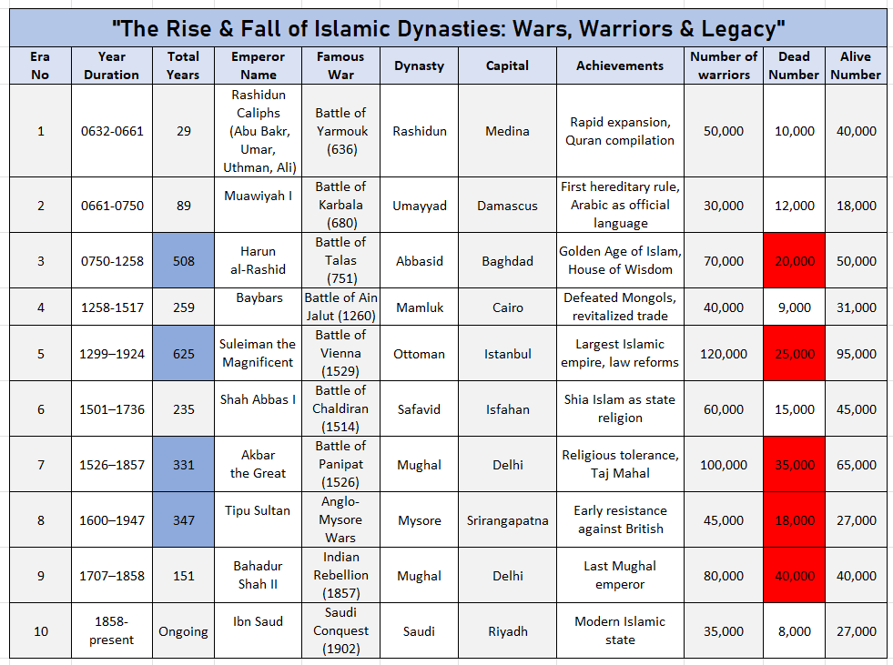

## 4.2 Bar Chart

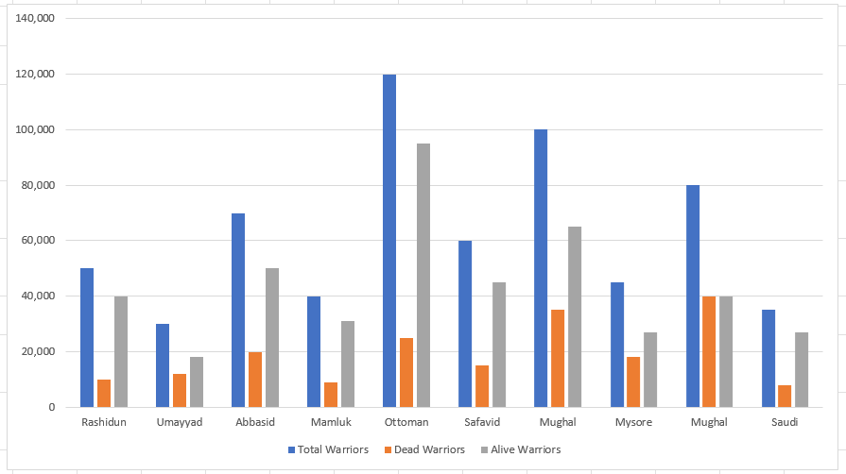

## 4.3 Pie Chart

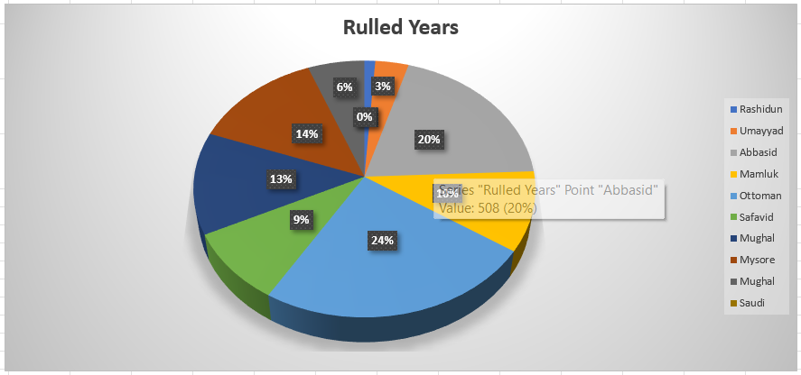

## 4.4 Operations Performed

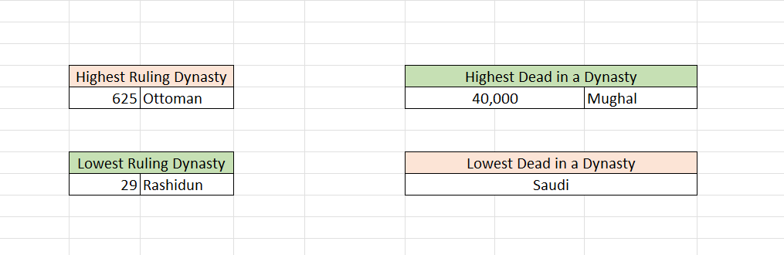

# Conclusion

This document and Excel analysis provide an in-depth understanding of Islamic history through data-driven insights. The rise and fall of these dynasties played a crucial role in shaping modern civilizations. By leveraging Excel functionalities, we can explore historical patterns and trends more efficiently.